Dear WCRIFG Members

Since the Solway Code of Conduct was issued for the 2016-2017 Luce Bay open season several members have been asking for the latitude and longitudes of the SAC Site boundaries including the areas open to mobile gears.

I appreciate that some people have had difficulty opening the document containing the details and hence have cut and pasted the relevant information below.

Am sending this message to all WCRIFG members for information and apologise to people for whom these details are not relevant.

Regards

Alastair

**Site**

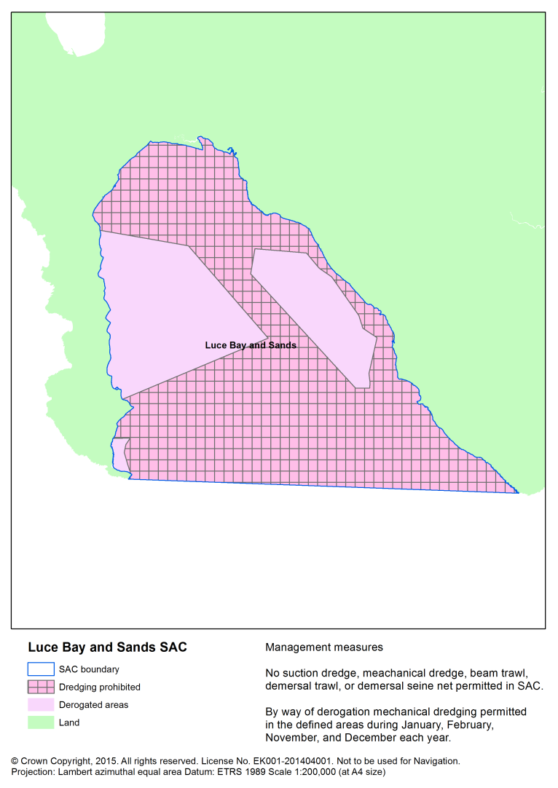

Luce Bay and Sands SAC **Site boundary**

co-ordinate “A” is 54°40.660 North latitude and 004°24.308 West longitude; and co-ordinate “B” is 54°38.028 North latitude and 004°51.340 West longitude.

The part of Scottish inshore waters, including the seabed and subsoil, which is enclosed by the boundary lines (the topographical descriptions of which are provided in the third column of the following table) which join in the order given the coordinates listed in the second column.

|  |  |  |
| --- | --- | --- |
| *Boundary Line* | *Co-ordinates between which the boundary line extends* | *Topographical description of boundary line* |
| 1. | A to B | Geodesic line |
| 2. | B to A | Line following the mean high water spring mark |

**Fishing methods not affected**

Hand line, rod & line, set nets, long lines, pelagic trawls, hand gathering and creel fishing.

**Fishing methods prohibited from whole site**

Beam trawl, suction dredge, demersal seine net, and demersal trawl.

**Fishing methods with zonal management arrangements**

Mechanical dredge is permitted in the following zones during January, February, November and December each year.  In all other parts of the sites the activity is not permitted.  The activity is not permitted at any other time of the year.

co-ordinate “C” is 54°47.652 North latitude and 004°56.936 West longitude; co-ordinate “D” is 54°47.772 North latitude and 004°50.623West longitude; co-ordinate “E” is 54°44.766 North latitude and 004°43.778 West longitude; and co-ordinate “F” is 54°41.142 North latitude and 004°52.911 West longitude.

The part of the Luce Bay Protected Area, including the seabed and subsoil, which is enclosed by the boundary lines (the topographical descriptions of which are provided in the third column of the following table) which join in the order given the coordinates listed in the second column.

|  |  |  |
| --- | --- | --- |
| *Boundary Line* | *Co-ordinates between which the boundary line extends* | *Topographical description of boundary line* |
| 1. | C to D | Geodesic line |
| 2. | D to E | Geodesic line |
| 3. | E to F | Geodesic line |
| 4. | F to C | Line following the mean high water spring mark |

co-ordinate “G” is 54°39.510 North latitude and 004°52.982 West longitude; co-ordinate “H” is 54°39.672 North latitude and 004°51.806West longitude; co-ordinate “I” is 54°39.366 North latitude and 004°52.009 West longitude; co-ordinate “J” is 54°39.048 North latitude and 004°52.001 West longitude; and co-ordinate “K” is 54°38.265 North latitude and 004°51.258 West longitude.

The part of the Luce Bay Protected Area, including the seabed and subsoil, which is enclosed by the boundary lines (the topographical descriptions of which are provided in the third column of the following table) which join in the order given the coordinates listed in the second column.

|  |  |  |
| --- | --- | --- |
| *Boundary Line* | *Co-ordinates between which the boundary line extends* | *Topographical description of boundary line* |
| 1. | G to H | Geodesic line |
| 2. | H to I | Geodesic line |
| 3. | I to J | Geodesic line |
| 4. | J to K | Geodesic line |
| 5. | K to G | Line following the mean high water spring mark |

co-ordinate “L” is 54°48.210 North latitude and 004°45.988 West longitude; co-ordinate “M” is 54°48.462 North latitude and 004°42.378West longitude; co-ordinate “N” is 54°47.964 North latitude and 004°41.269 West longitude; co-ordinate “O” is 54°47.724 North latitude and 004°40.303 West longitude; co-ordinate “P” is 54°46.410 North latitude and 004°37.858 West longitude; co-ordinate “Q” is 54°45.942 North latitude and 004°37.404 West longitude; co-ordinate “R” is 54°45.678 North latitude and 004°36.285 West longitude; co-ordinate “S” is 54°44.196 North latitude and 004°36.328 West longitude; co-ordinate “T” is 54°43.824 North latitude and 004°36.103West longitude; co-ordinate “U” is 54°43.626 North latitude and 004°36.065 West longitude: co-ordinate “V” is 54°43.506 North latitude and 004°37.046 West longitude; and co-ordinate “W” is 54°47.178 North latitude and 004°45.916 West longitude.

The part of the Luce Bay Protected Area, including the seabed and subsoil, which is enclosed by the boundary lines (the topographical descriptions of which are provided in the third column of the following table) which join in the order given the coordinates listed in the second column.

|  |  |  |
| --- | --- | --- |
| *Boundary*  *Line* | *Co-ordinates between which the boundary line extends* | *Topographical description of boundary line* |
| 1. | L to M | Geodesic line |
| 2. | M to N | Geodesic line |
| 3. | N to O | Geodesic line |
| 4. | O to P | Geodesic line |
| 5. | P to Q | Geodesic line |
| 6. | Q to R | Geodesic line |
| 7. | R to S | Geodesic line |
| 8. | S to T | Geodesic line |
| 9. | T to U | Geodesic line |
| 10. | U to V | Geodesic line |
| 11. | V to W | Geodesic line |
| 12. | W to L | Geodesic line |